The train station and the bus station are nearby. Sit into trolley bus №2. Ride 20-30 minutes. (Ticket can be bought from the driver 1 €.)
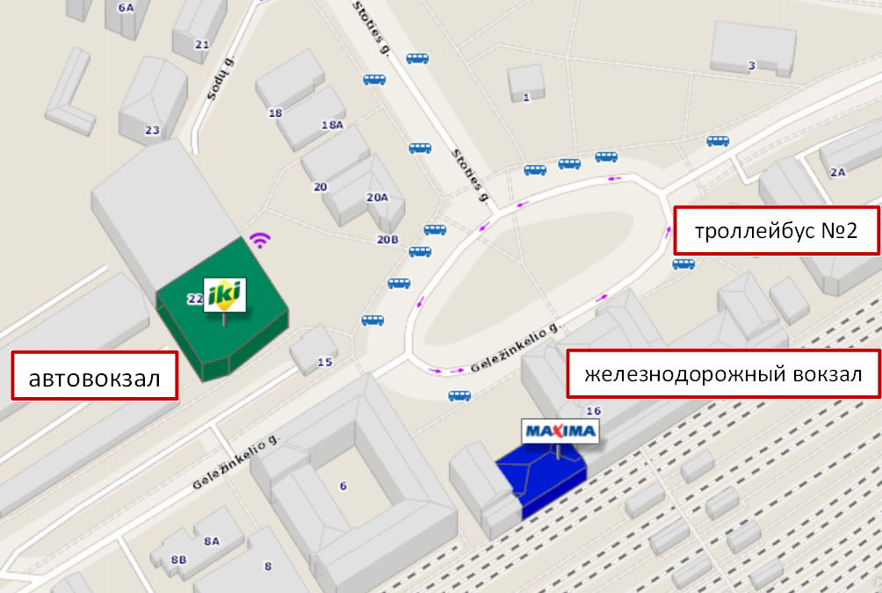
Stop the SILO TILTAS (Bridge of Pine Forest), go to the Academy for 2 minutes.
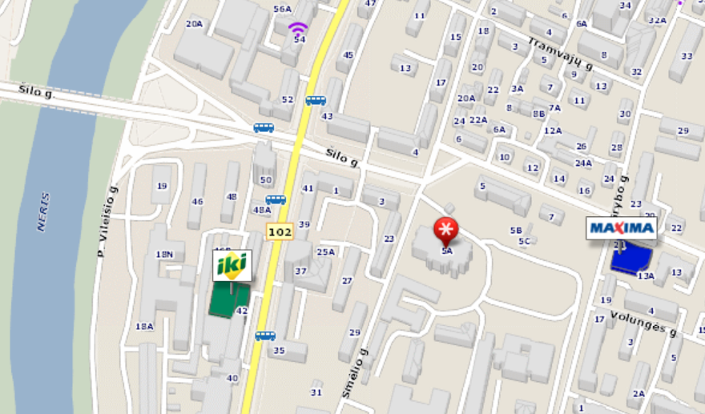

From the airport ride 40 minutes from the transfer. Take the bus №3G, go to the stop of Mikalojus Konstantinas Čiurlionis (the sixth stop). Transfer to trolley bus # 4.
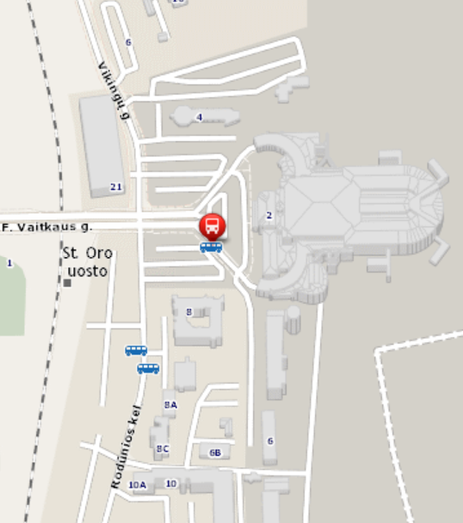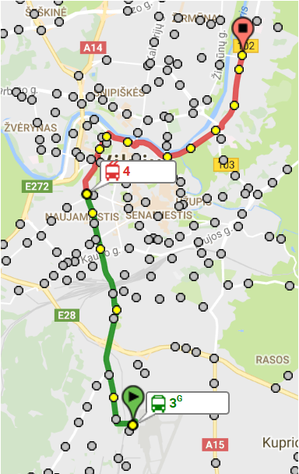
airport
Stop the SILO TILTAS (Bridge of Pine Forest), go to the Academy for 2 minutes.

